
Thompson Turkey Trot
5K Trail Run and 3K Wobble (Walk)
Sunday, November 9, 2025
Supporting Thompson Trails, Parks, Recreation & TEGG!

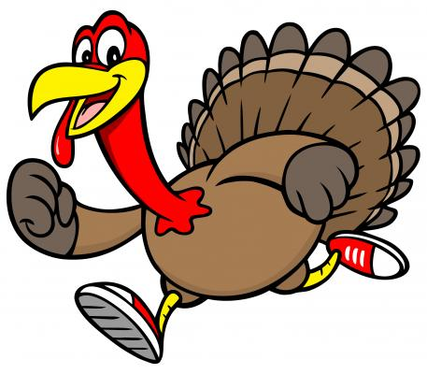
Where: West Thompson Dam, Thompson, CT

When: 8:30am Check In – 10:00am START TIME

Entry fee: $25 - registration on/before 10/31 includes T-Shirt
$25 – registration after 10/31 no T-shirt
No Pets Please.

Just People

$30 – DAY OF REGISTRATION FEE
Pre-registration by noon on Friday November 7th
Mail registration form to
Recreation Office
PO Box 899
North Grosvendordale, CT 06255
RACE AWARDS:
For top overall male and female, top three male and female in each age category.
TEAM AWARDS:
Award to the team with the most members / top performance
COSTUMES ENOURAGED!
Dress in festive Thanksgiving & Turkey gear! A prize will go to the best dressed!

KIDS FUN RUN:
No registration required! ¼ mile fun run at 9:30am! Open to kids age 12 and under.

DOGS WELCOME!
Bring a leashed, furry friend to join you on the 3K Wobble! (No dogs on 5K trail run)

————————————————————————----—————————————————————————

Turkey Trot Registration (Check one):  5K Trail Run 3K Walk

Name: ______________________________________________________ Date of Birth: ___________________
Mailing Address: ___________________________________________ Male: ____ Female: _____Open____
Town: ____________________________________________________ State: ___________ Zip: __________________
Call: _____________________________________ E-Mail: _______________________________________
Team Name (if applicable):
Division: 12 & Under 13-18 19-29 30-39 40-49 50-59 60+

Shirt Size: Youth L Youth XL Adult S Adult M Adult L Adult XL Adult XXL
No Shirt

Payment Type: Check Cash (Check Payable to Thompson Recreation)

Sponsors ONLY Free entry (Sponsor Name______________________________)

How did you hear about the event? _______________________________________________________

If under 18, Parent Name:______________________________Parent DOB:
Parent Phone: ________________________
Parent Email: _____________________________________
In signing this form, I for myself, my heirs, executors, and administrators, release Thompson Recreation and Thompson Trails Committee, The Town of Thompson, the race directors, the volunteers, and all sponsors of this race from all liability in the case of injury received as a result of participation in this run. I give permission for the Town of Thompson & Race Organizers to produce photos & videos of myself or my child for promotion materials. In case of a minor (under 18) this form must be signed by the parent or guardian of entrant. Under age 12 must be accompanied by an adult.

Signature (if minor, parent or guardian) Date:

